The London Olympics
The Olympics Games is a major international event featuring summer and winter sports. They are held every two years with the summer and winter games alternating. Around 31 sports are included in the Games including gymnastics, diving, judo and table tennis. Around 200 nations take part in the Olympic Games and they are regarded as the world’s foremost sports competition. In 2012, London will host the Summer Olympics for the third time. London has hosted the Olympics on two past occasions, in 1908 and 1948. The USA is the only country that has hosted the Summer Olympics more than the UK. In 1908, it was only the forth Olympic Games, they were supposed to take place in Rome but the eruption of Mount Vesuvius meant that the Italian government had to redirect their funds. The bid for the 2012 Olympic Games was won in July 2005 and they are planned to take place between the 27th July and the 12th August 2012.
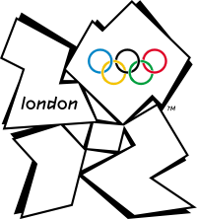

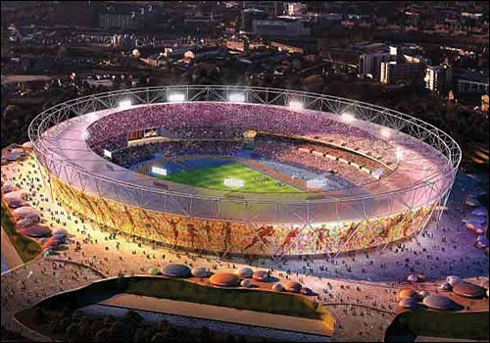

Questions:
- How often are the Olympic Games held?
_________________________________________________________________________________________________
- How many sports are included? Name 2 of then.
__________________________________________________________________________________________________
- How many times have London hosted the Olympic Games?
__________________________________________________________________________________________________
- Why did the Olympic Games take place in London in 1908?
__________________________________________________________________________________________________
- Which country has hosted the most Olympic Games?
__________________________________________________________________________________________________
- When will the Games take place?
______________________________________________________________________________________________

